Biplab Thapa Magar

OPL – Fall 2020

Manual for Pinochle for Prolog

**Bug Report**

Bugs encountered with AI meld and chase card suggestion during demo. I tried to fix the bugs and AI seems to work better from what I have observed

**Feature Report:**

Missing features:

All features have been implemented

Extra features:

No extra features were implemented

**Description of Data Structures:**

**Hand:** Contains the list of all the hands of a player in a round of pinochle. Is simply a list of all the cards that the prayer possesses. Each card is represented as an integer ranging from 0 to 47

**CapturePile:** Contains the list of all the capture pile cards of a player in a round of pinochle. Is simply a list of all the cards that the prayer possesses in his capture pile. Each card is represented as an integer ranging from 0 to 47

**Meld:** Stores all the melds played by a player. The meld is a list of lists of lists. The outer most list consists of 9 lists (9 standing for the total number of meld types in Pinochle). Each of these 9 lists stands for one meld type. Each of these 9 lists contains melds of its own type. These melds are also lists that are comprise of lists of cards that are used to form the meld.

**Log**

**-**Nov 29, 2020

-Came up with the general design for the program

Total: 4 hours

-Nov 30, 2020

-Created all the clauses that interpret the card rank and suit based on card id

-Created facts that determine a rank’s or a suit’s string representation and index

-Created clauses to get card string given id

-Created clauses to create and shuffle a deck for the game

Total: 3 hours

-Dec 1, 2020

-implemented clauses to start the game, prompt user for ‘new’ or ‘load’ game

-Implement beginning a new game of pinochle and setting up a new round of pinochle

-added clauses to print a list of cards (for printing capture pile and hands)

Total: 4 hours

-Dec 2, 2020

-implemented round loop and round logic, including determining which card wins in a round, who goes next, what the next move will be

-implemented prompting user for next move

Total: 3 hours

-Dec 3, 2020

-Debugged the clause related to round loop and setting up new round .

-Added clause that makes computer play a lead card and prompts human to play a lead card

-Added clause that makes the computer play a chase card and prompts human to play a case card

-Added basic meld-related facts and rules that generate meld points

Total: 4.5 hours

-Dec 4, 2020

-Added the clauses that for the logic of suggesting lead card

-Added the clauses for logic of suggesting chase card

-Added clause for determining what cards, when thrown preserve the best melds

Total: 4 hour

-Dec 6, 2020

-Created clauses for logic of recommending meld to play

-Created clauses for accepting user input for melds to play

-Added clause for determining what melds can be played from the current hand

-Debugged clauses for suggesting cards that had to do with backtracking issues

Total: 11 hours

-Dec 7, 2020

-Added clauses to prompt player for melds to play

-Tested and ran the a game of Pinochle

-Fixed multiple bugs relating to AI logic.

-Fixed clauses that prompt player for melds to play

-Fixed bugs in the round_loop clause

Total: 11 hours

-Dec 8, 2020

-Implement saving and loading games, although not in the format specified in project description.

Total: 3 hours

Dec 9, 2020

-Implemented saving and loading games in the specified format

Total: 10 hours

Dec 11, 2020

-Fixed bugs in AI logic that suggested incorrect melds and non-ideal lead and chase cards

Total: 3 hours

**How to Run**

1. In terminal, navigate into the src directory
2. Enter “swipl” into the terminal and press enter
3. Enter “[pinochle].” into the terminal and press enter
4. Enter “start_game.” to start the game

**Screenshots**

1. Starting a game

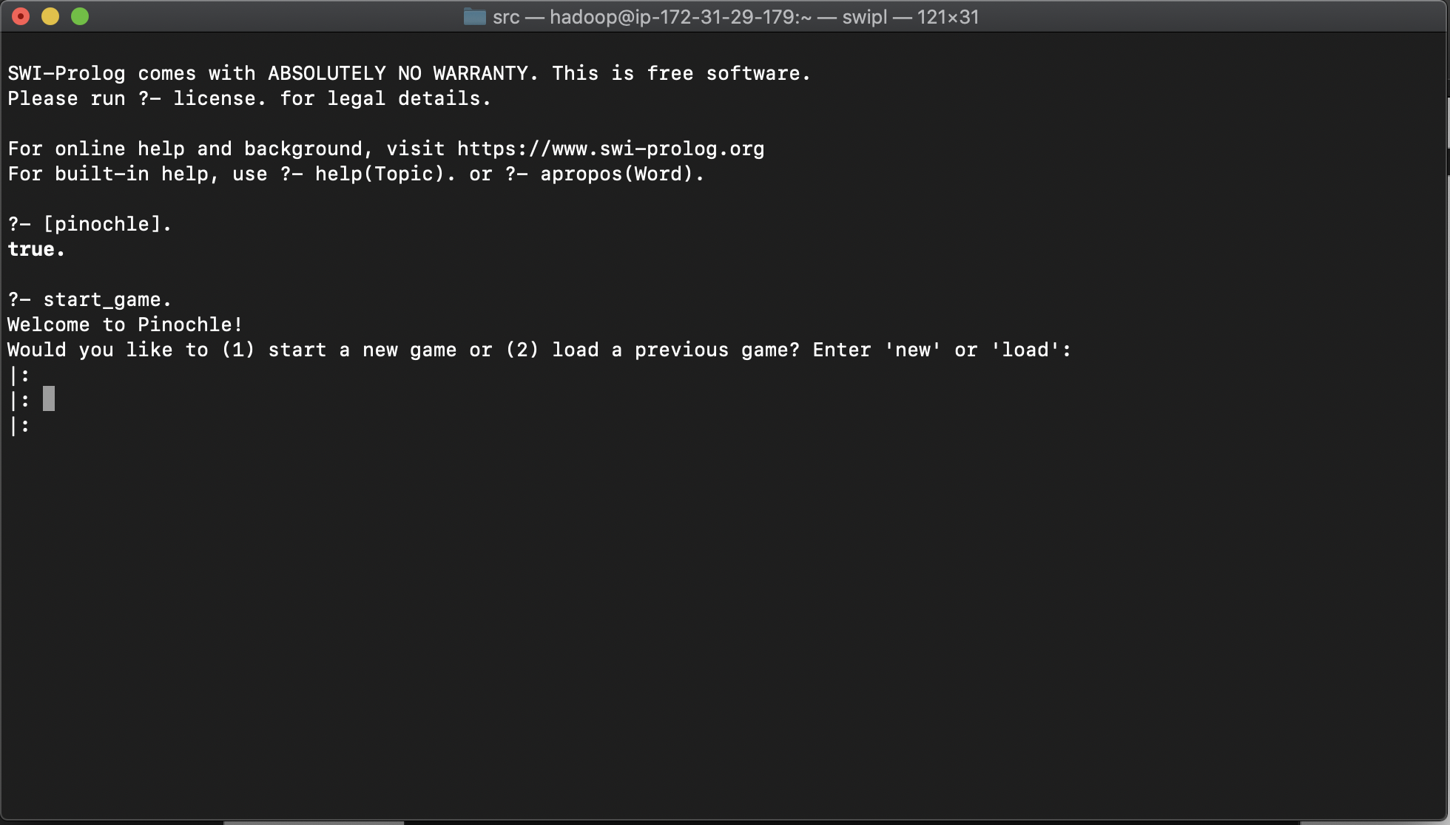

1. Starting a new game

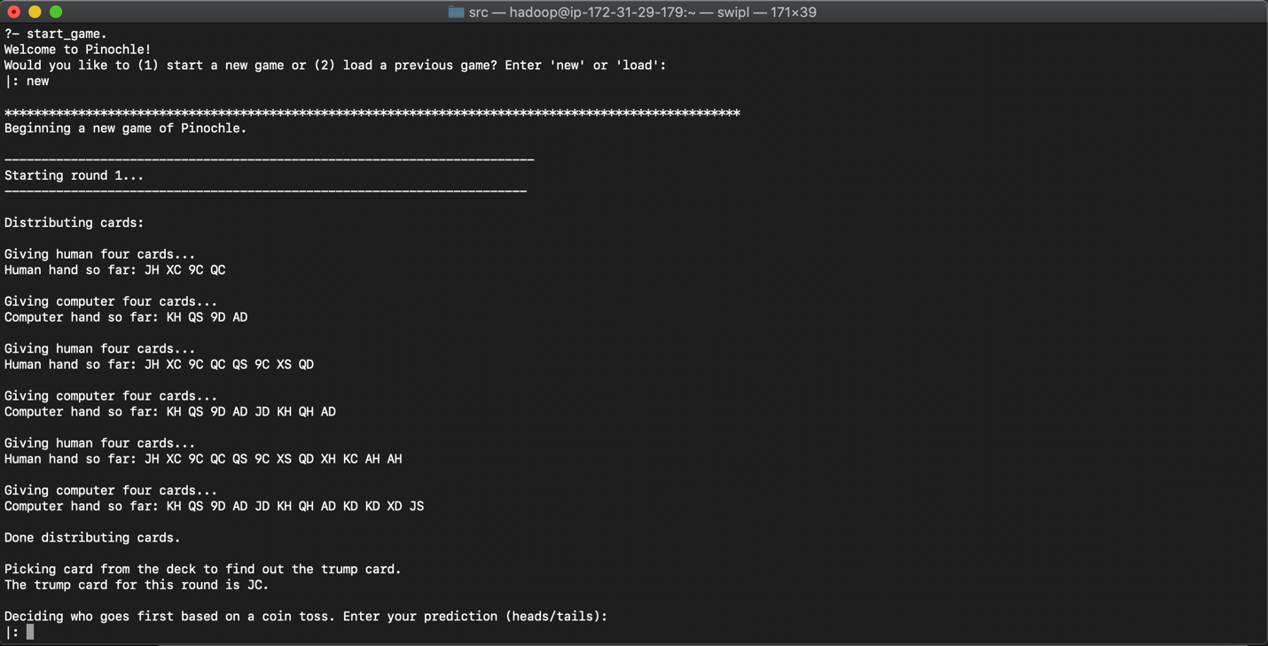

1. Coin toss

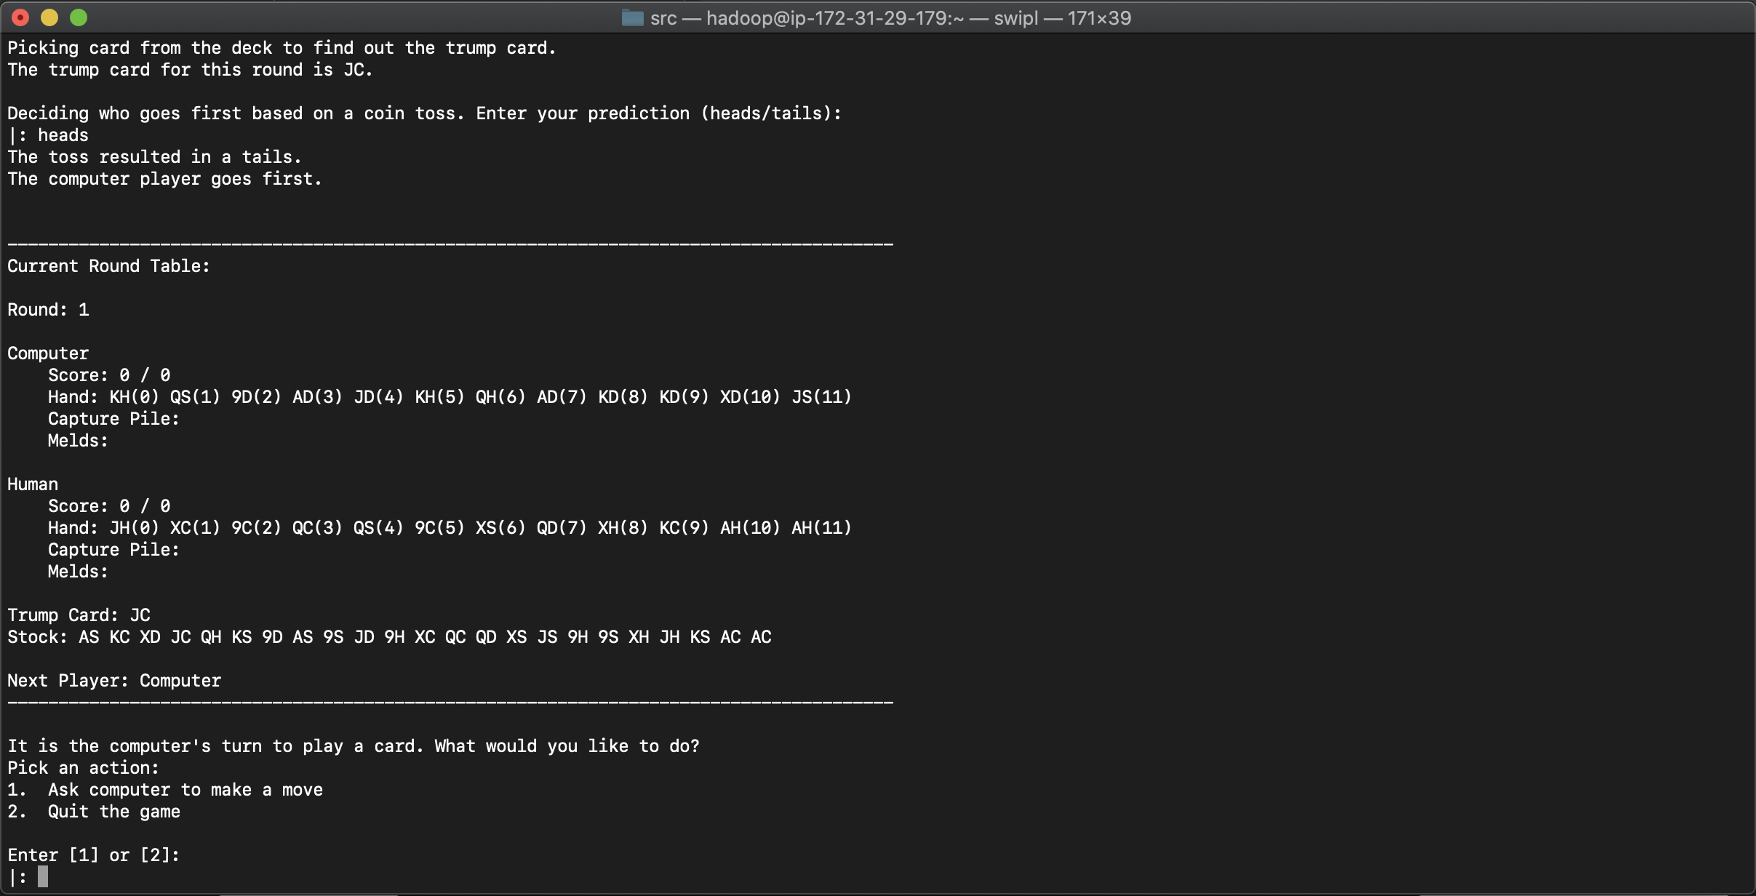

1. Asking computer to make a move

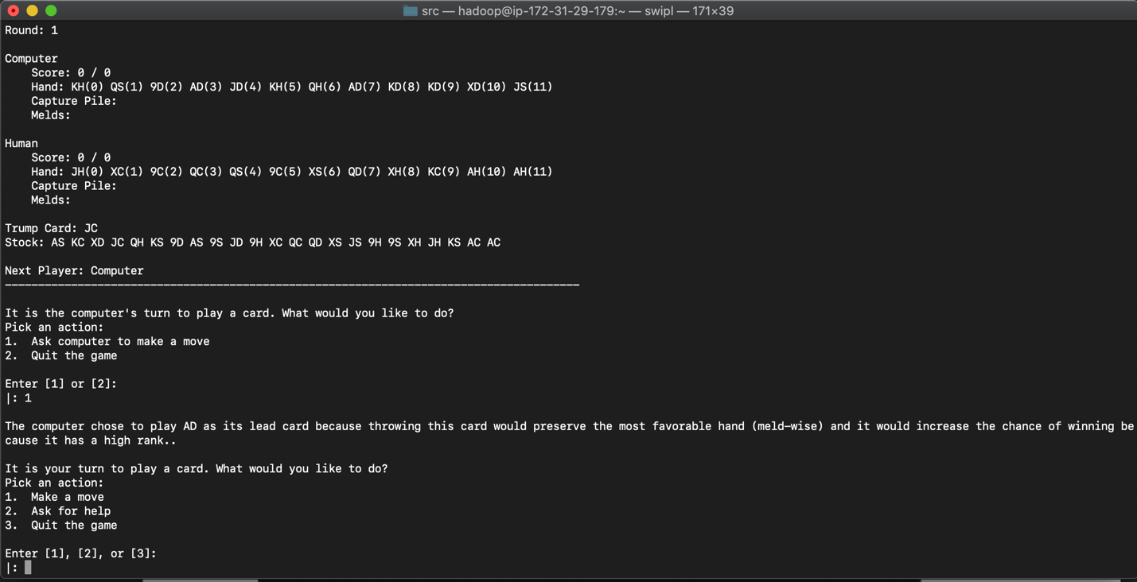

1. Asking for help throwing a lead card
2. Asking for help throwing a chase card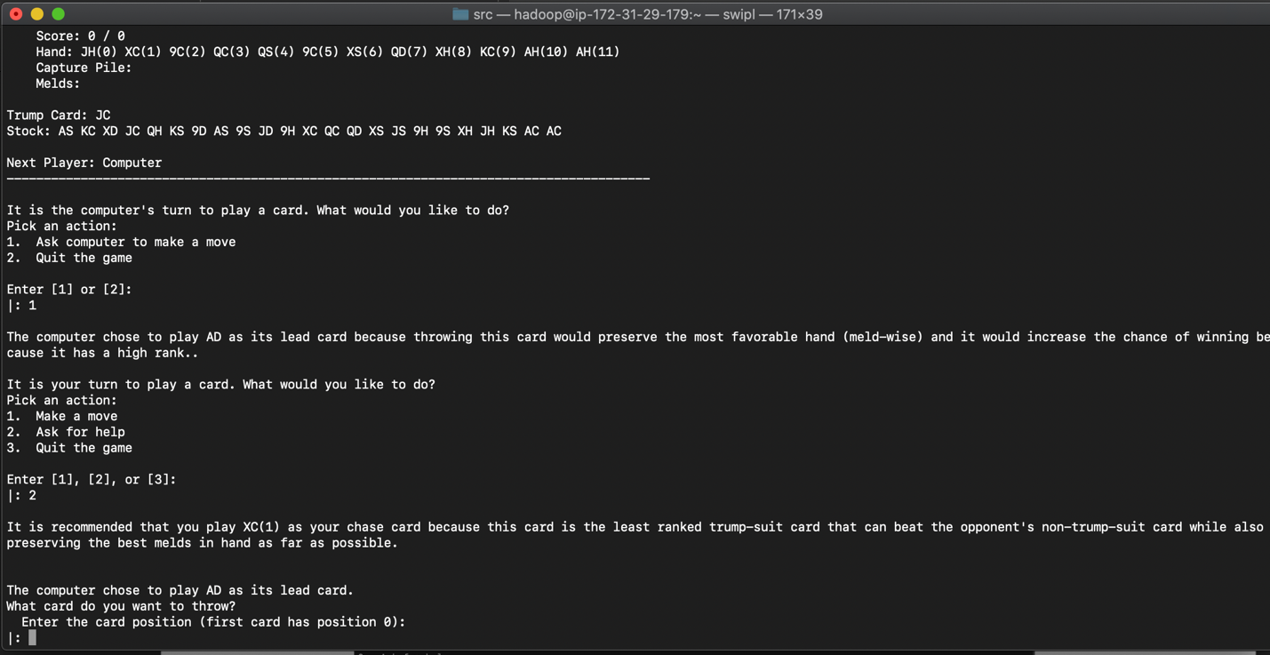
3. Human making a move and Computer Winning a turn

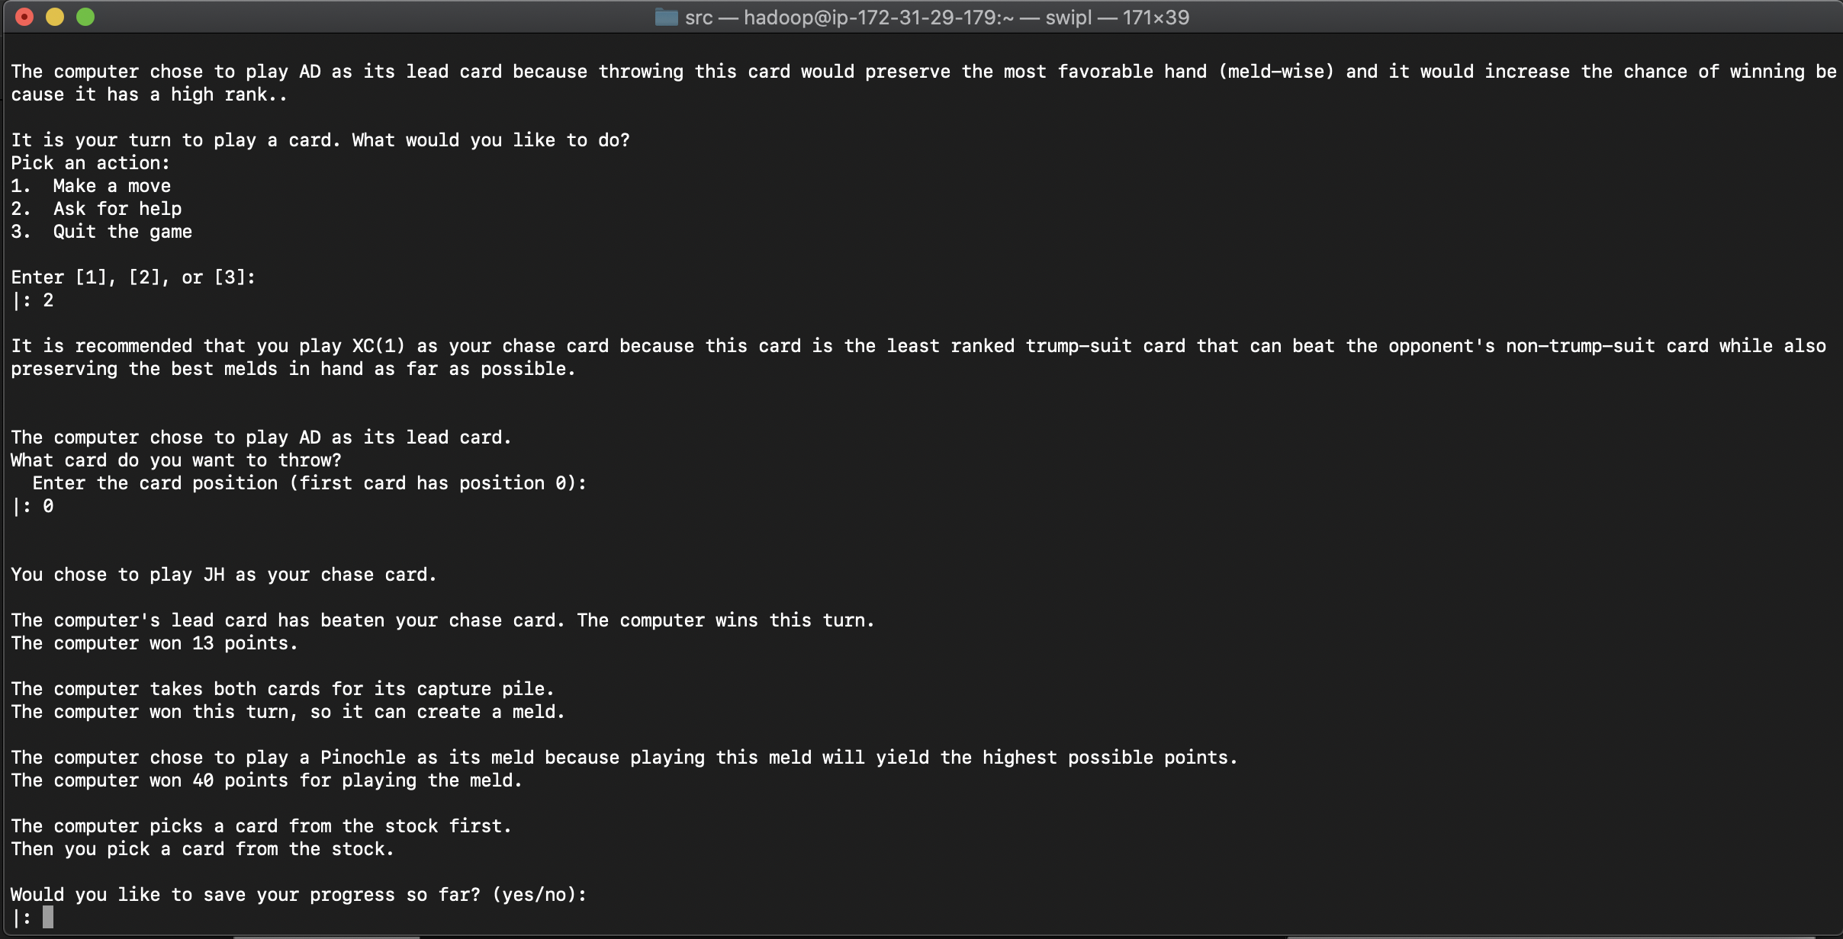

1. Human winning and being prompted to create a meld

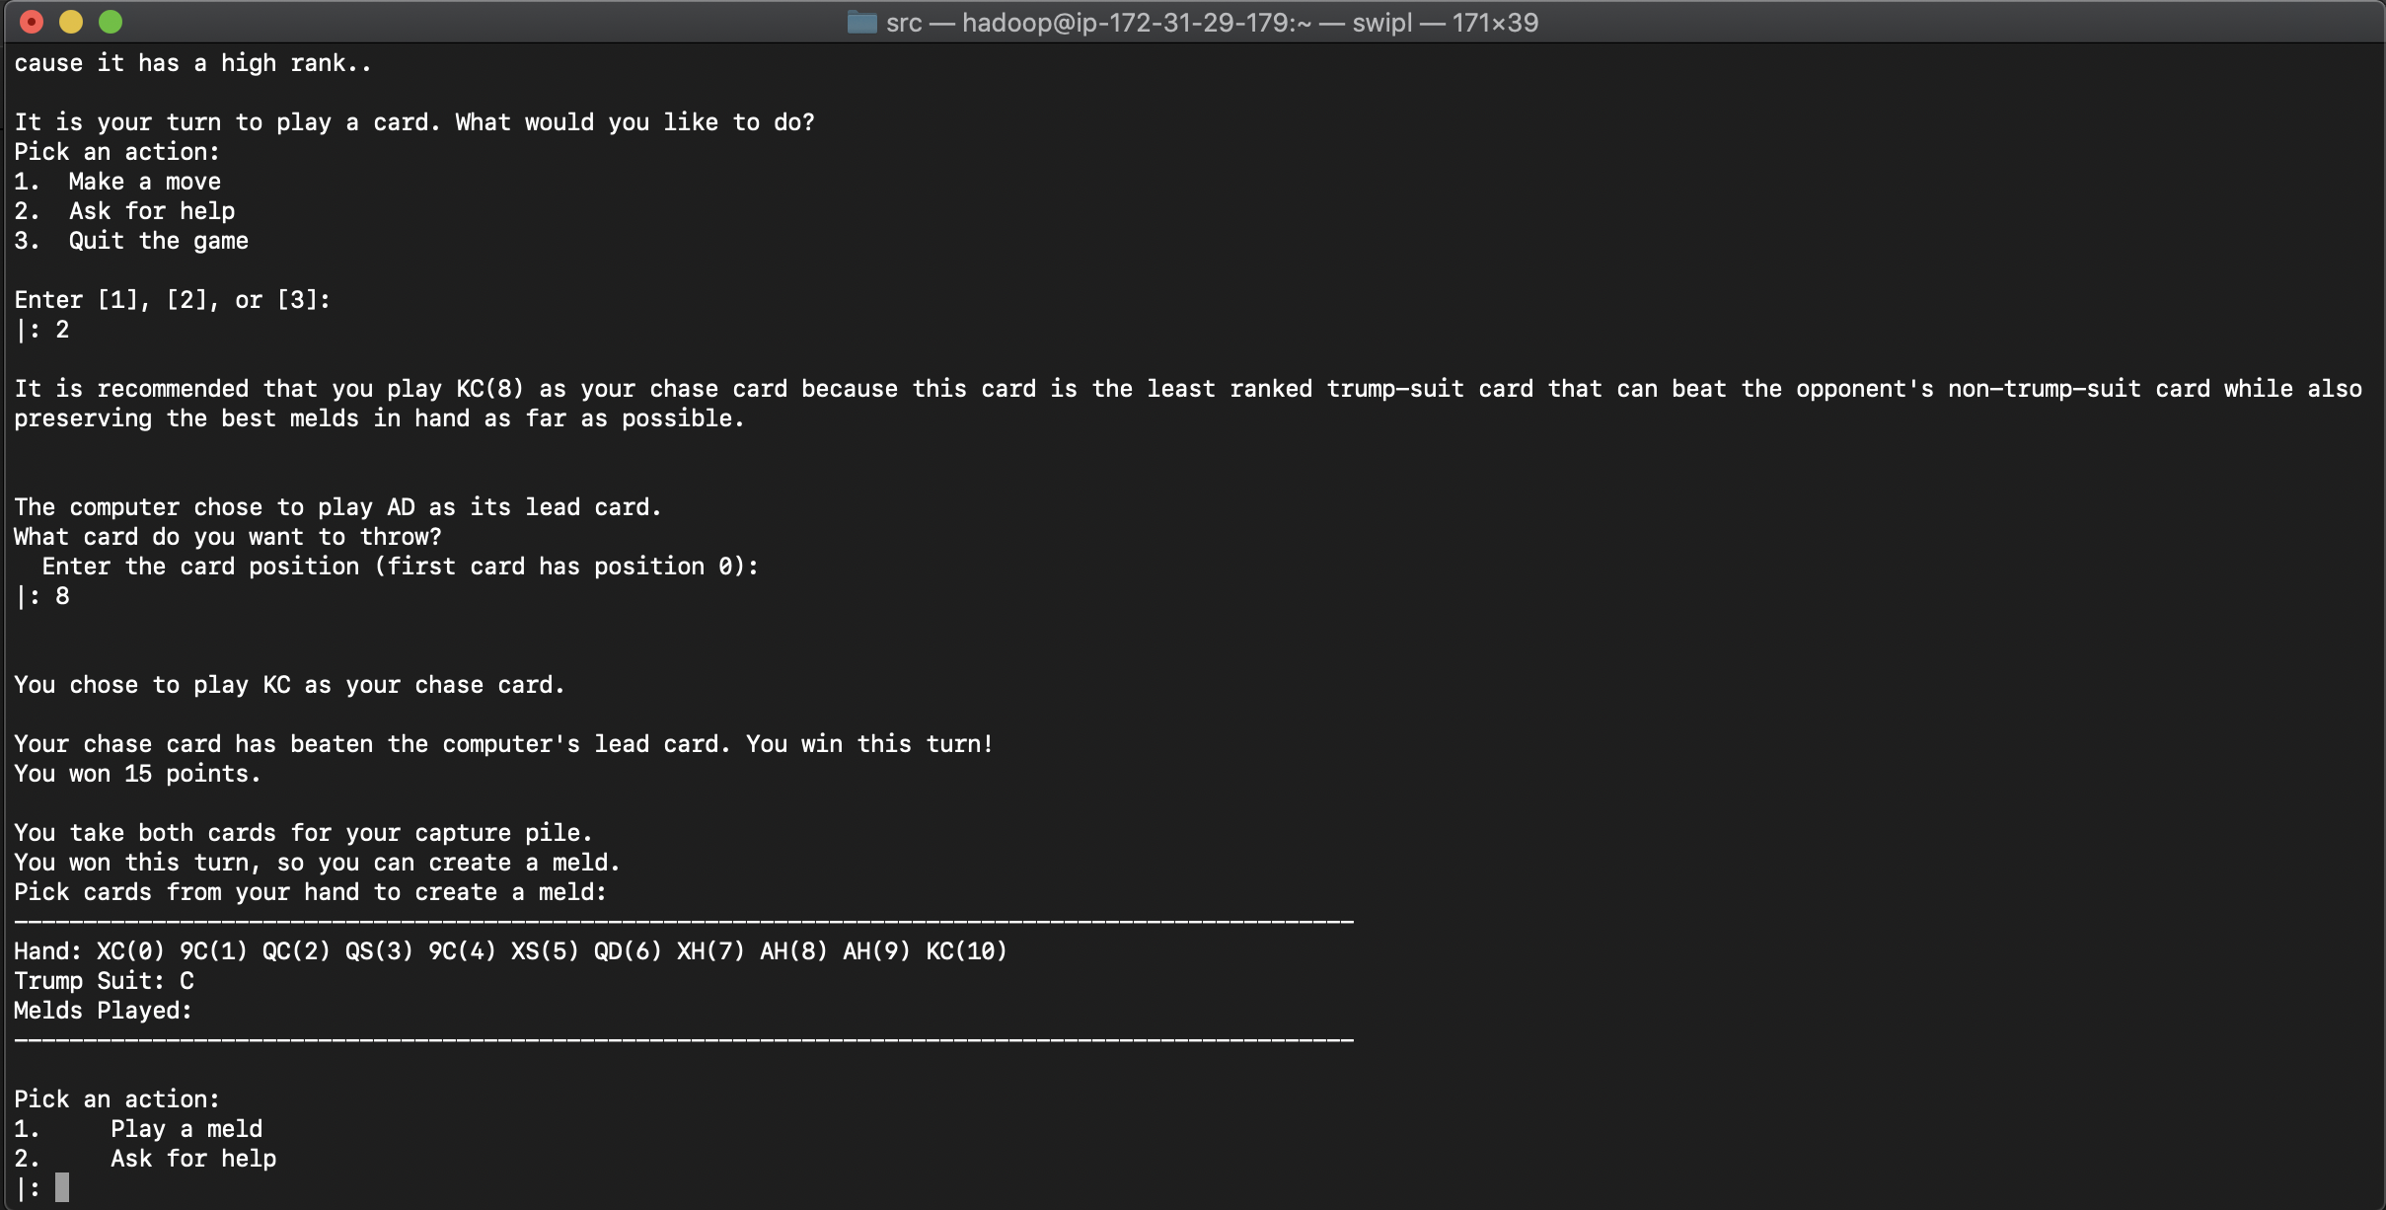

1. Asking for help for a meld

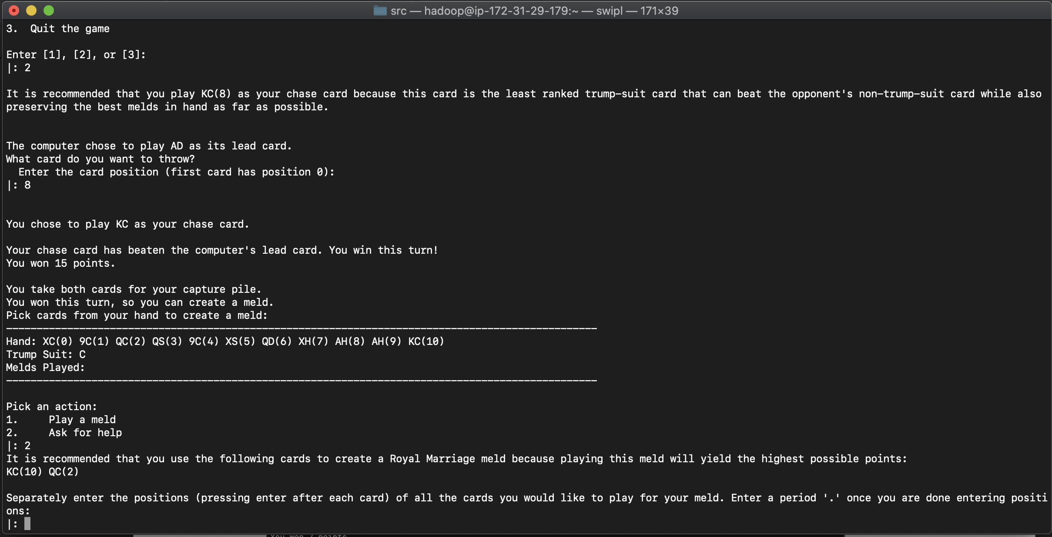

1. Human creating a meld

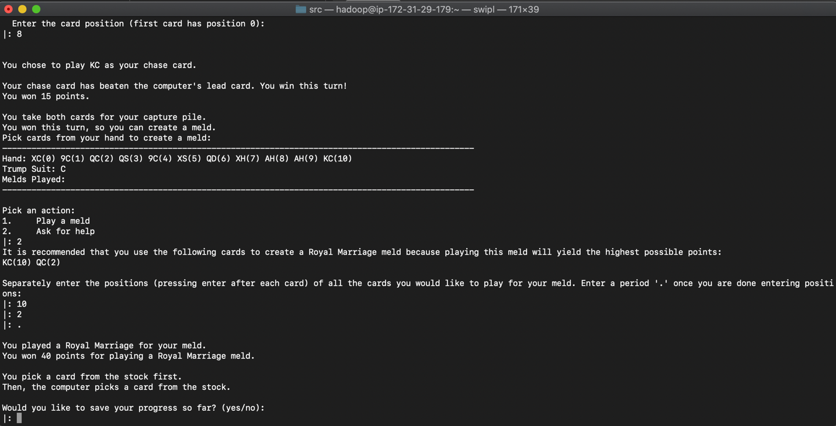

1. Round end and Asking if user wants to play another round

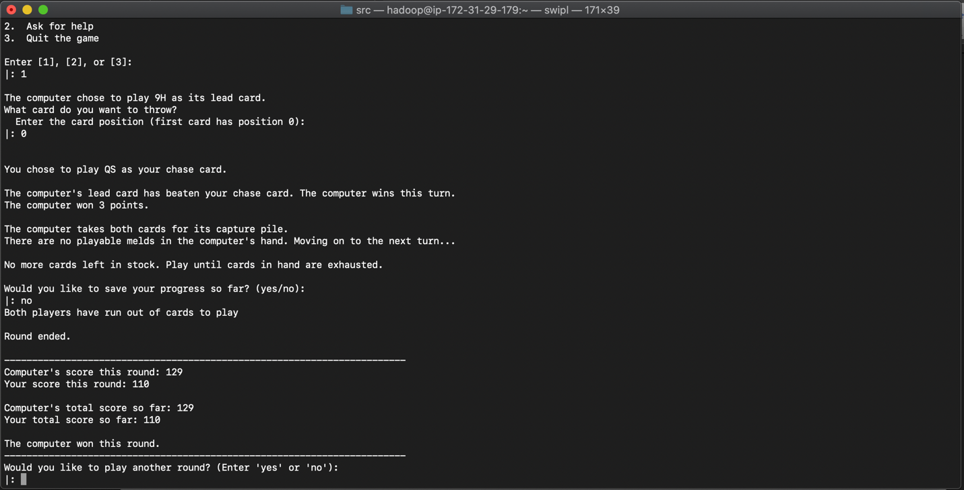

1. Player refusing to play another round and winner declaration

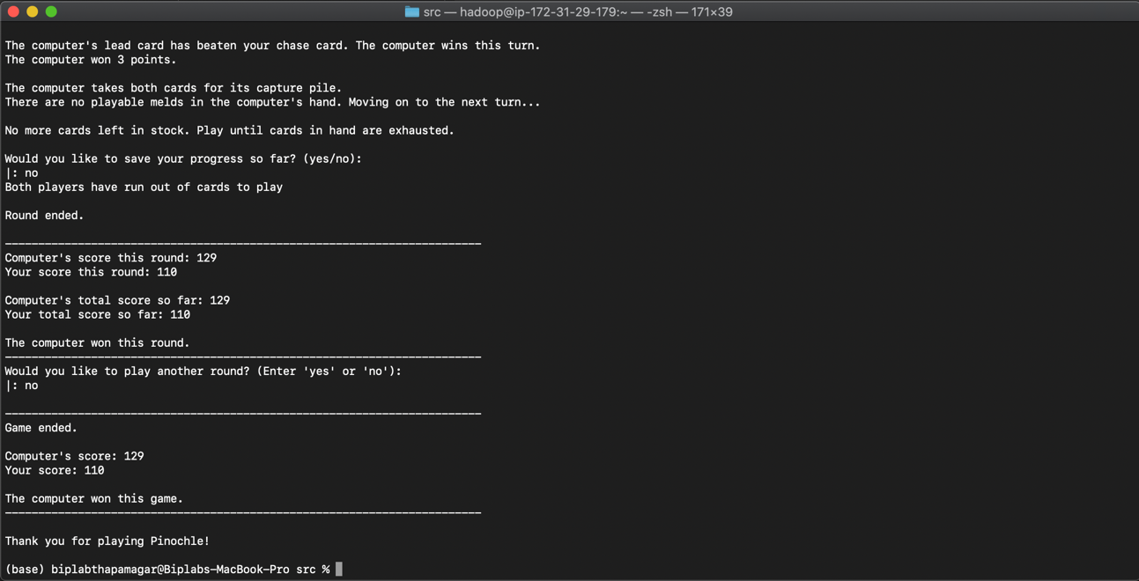

1. Loading a previous game from a save file

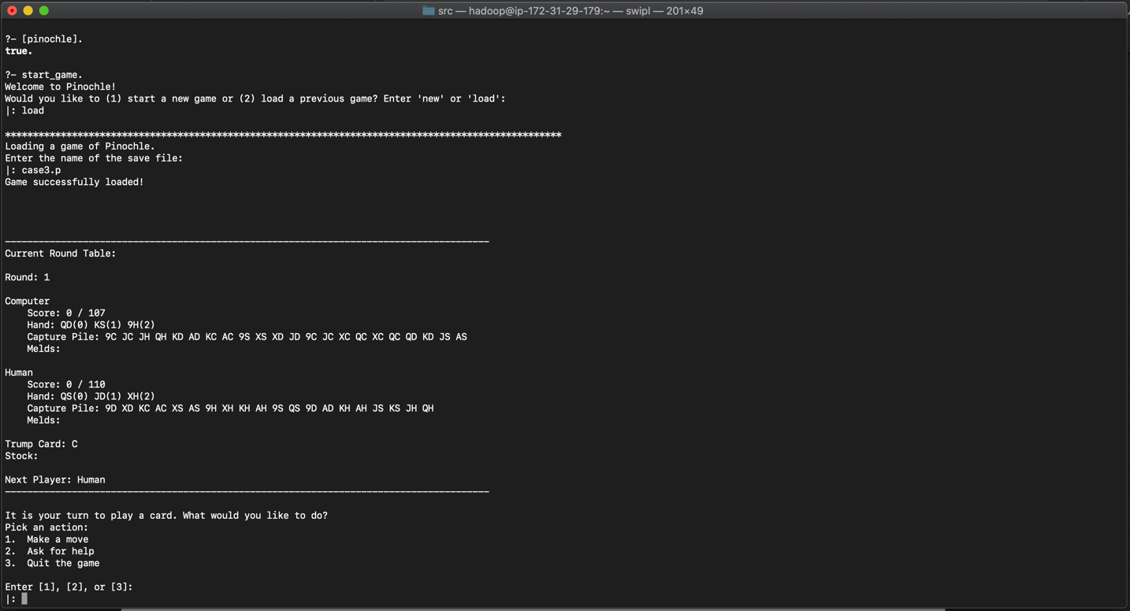

1. Player quitting in the middle of a game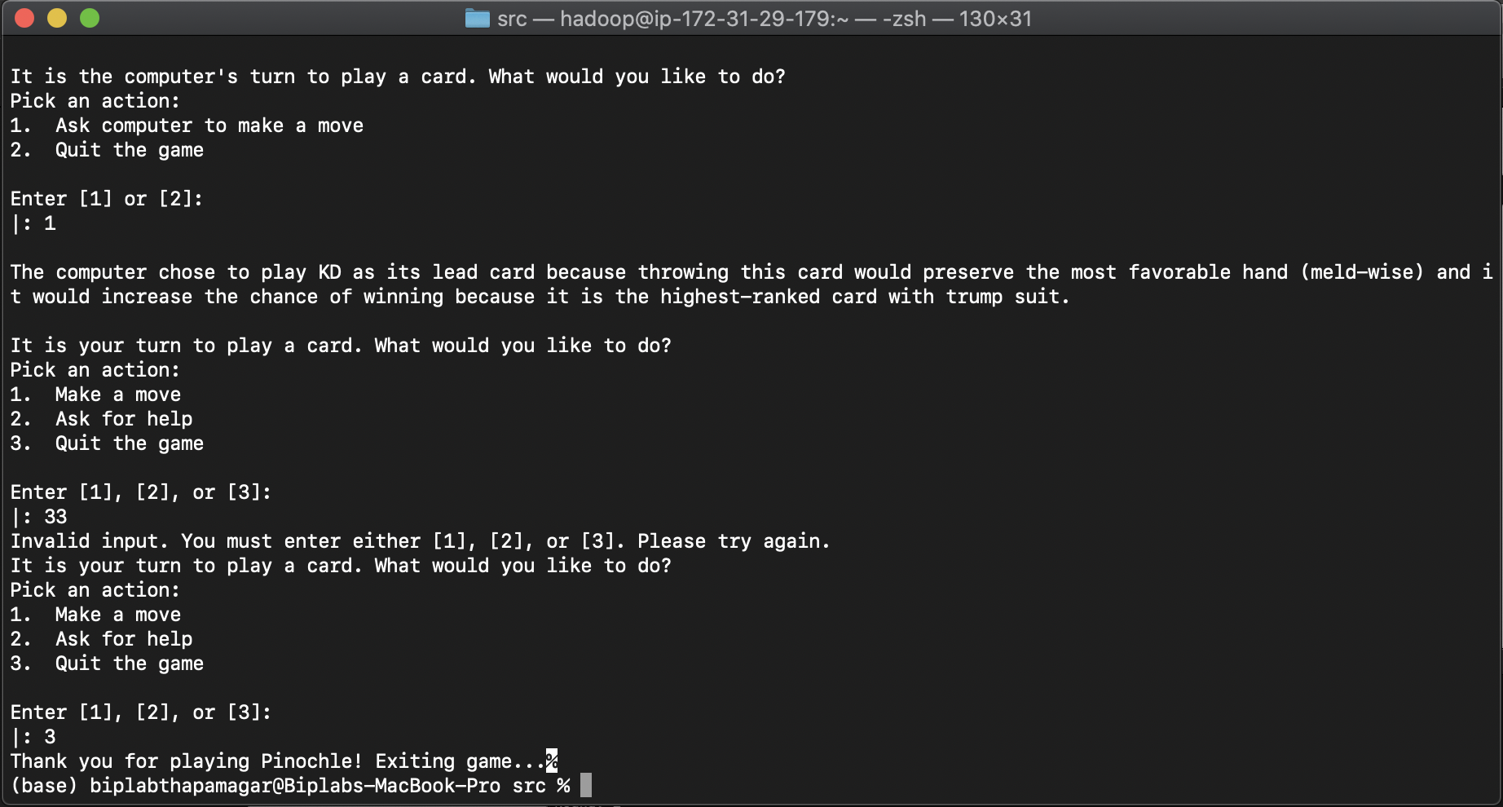
2. Saving a game

